***NAME:CH.PARDHIV***

***REG NO:192124031***

***DEPT: AI&DS***

3.CONNECTIVITY PROGRAM FOR PAYROLL SYSTEM

FORM:-

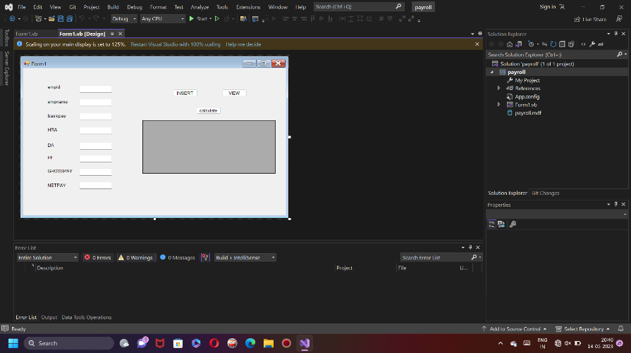

DATABASE:-

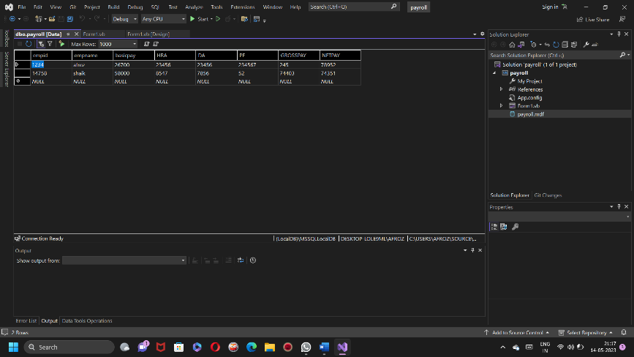

CODE:-

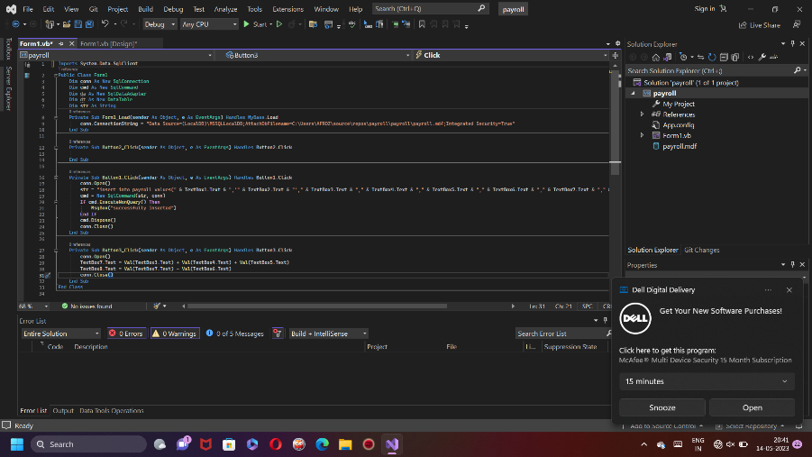

OUTPUT:-

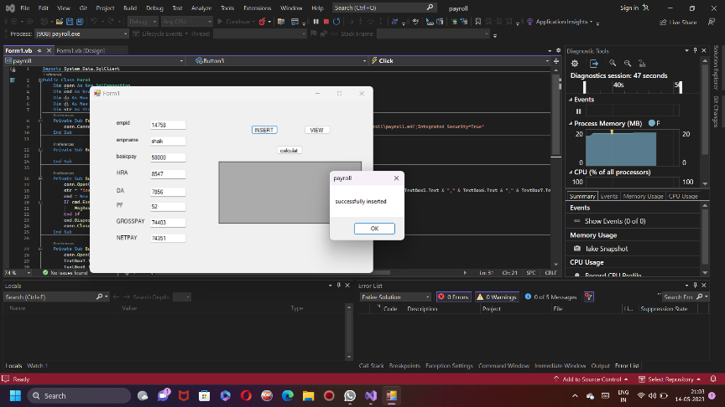

4.CONNECTIVITY PROGRAM FOR STUDENT MARKSHEET

FORM:-

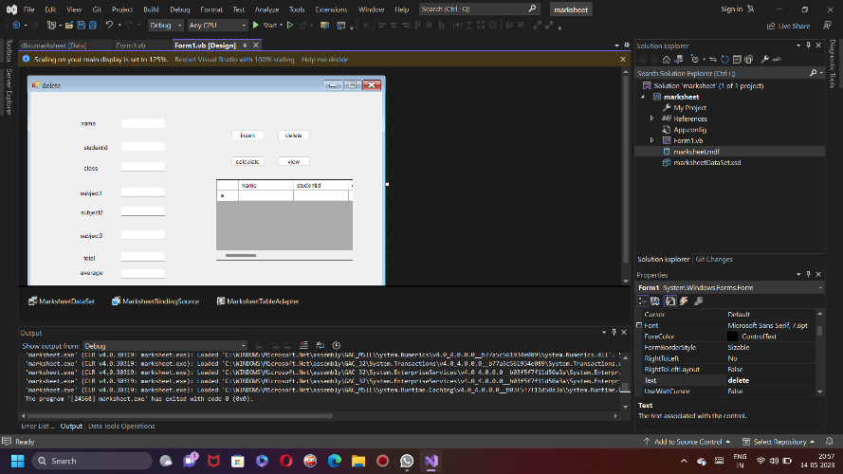

DATABASE:-

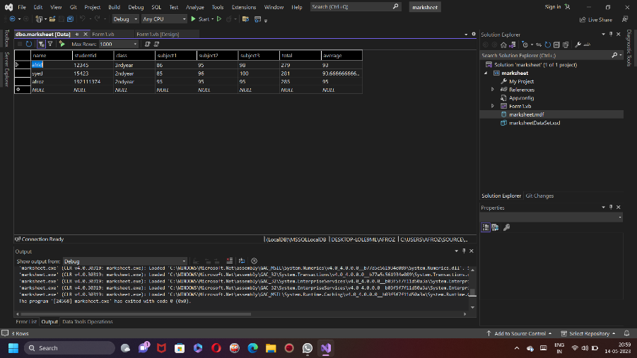

CODE:-

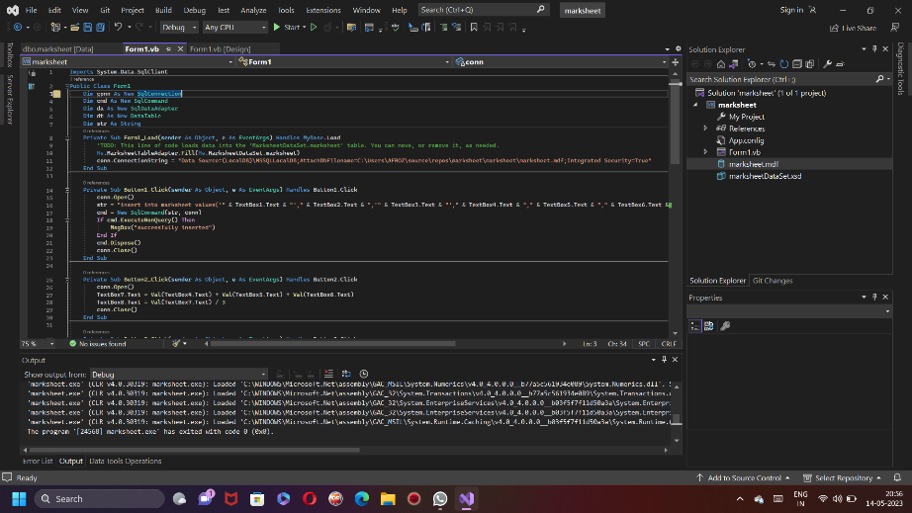

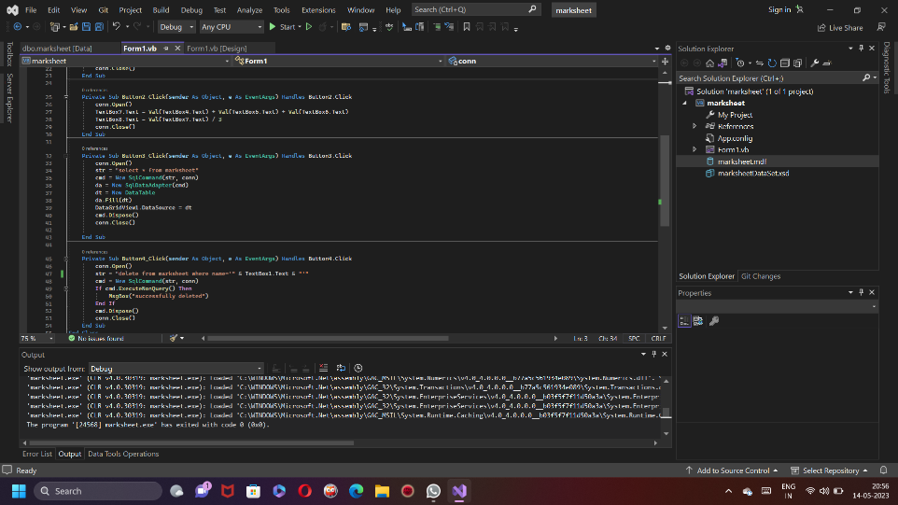

OUTPUT:-

